

**Battery Protection Tech Report  
American Solar Challenge 2014  
November 15, 2013**

**Compiled by:**

|  |  |  |
| --- | --- | --- |
| *Name* | *Title* | *E-mail* |
| Michael Bot | Electrical Co-Manager | botmr@mcmaster.ca |
| Mhamad Salih  Andy Li | Electrical Co-Manager  Electrical Co-Manager | salihm@mcmaster.ca  liy92@mcmaster.ca |

McMaster Solar Car Project

McMaster University

Hamilton, Ontario, Canada

solarcar@mcmaster.ca

(905) 525-9140 ext. 27388

www.macsolarcar.com

**Table of Contents**

1 Introduction 1

2 Battery Pack Specifications 1

3 System Methodology 2

3.1 Protection System Set Points 2

3.2 Battery Protection System Design 2

3.2.1 System Overview 2

3.2.2 Battery Side Monitor 3

3.2.3 Current Transducer 4

3.2.4 Central Processor 4

3.2.5 Additional Outputs and Debugging Support 5

4 Regulations Compliance and Scrutineering Demonstration 5

5 Concluding Remarks 6

# Introduction

The following report reviews the planned battery protection system (BPS) to be employed in the McMaster Solar Car Project’s (MSCP) entry into ASC2014.

A lithium polymer (LiPo) battery pack will be used in our ASC2014 entry. As such, the battery pack will employ fully active protection for over-voltage, under-voltage, over-temperature, and over-current conditions. Voltage and temperature measurements are taken down to the module level while a single current measurement is taken in series with the positive terminal of the battery pack. The measurements are digitized and monitored by a microcontroller.

In series with the battery pack positive terminal is a normally-open, non-latching contactor. If a measurement outside of the allowed limits is detected, a fault condition is recorded. Under a fault condition, the battery protection microcontroller removes the power supply to this contactor, electrically isolating the battery pack from the rest of the car. The protection system and disconnect contactor are installed within the battery enclosure such that the battery pack connector terminal is electrically isolated from the pack when the vehicle is switched off and the enclosure is removed for impound. In addition to the active protection elements listed above, a 100A fuse is also installed in series with the positive terminal as an added passive protection device.

As the battery protection system is still in development, some details have yet to be finalized and specifications may change. Should any major changes in design occur, we will notify ASC organizers as soon as possible. If any details are unclear we would be happy to answer any questions that the reviewers may have.

# Battery Pack Specifications

The main battery pack will be constructed of 52 Southtop model 9989182 LiPo cells; the relevant specifications are identified below in Table 1. In race configuration, two cells are placed in parallel per module and 26 modules are placed in series. Since two cells are placed in parallel per module, the current limits for the battery pack are twice that of a single cell.

Table 1: South Top 9989182 LiPo Specifications

|  |  |  |
| --- | --- | --- |
| **Item** | **Specifications** | **Comments** |
| Nominal voltage | 3.70 V |  |
| Charge cut-off voltage | 4.20 V |  |
| Discharge cut-off voltage | 2.75 V |  |
| Nominal capacity | 20.000 Ah ± 5% (74 Wh) | 0.2C discharge rate (4 A) |
| Discharge current | Standard: 4 A  Maximum: 40 A | Allowable temperature range:  -20°C - 60°C |
| Charge current | Standard: 4 A  Maximum: 20 A | Allowable temperature range:  0°C - 45°C |
| Maximum cell mass | 375 g |  |
| Cell cost | US $35.00 |  |

# System Methodology

## Protection System Set Points

From Table 1, the relevant battery protection system set-points were identified, along with the required actions of the battery protection system:

* Over-voltage
  + 4.10 V: if any module voltage exceeds 4.10 V, the battery pack is nearly fully charged. A warning is given to the driver via an indicator lamp and to the support crew over telemetry.
  + 4.20 V: if any module voltage exceeds 4.20 V, the battery pack is automatically electrically isolated from the vehicle and all measurement circuitry is disconnected.
* Under-voltage
  + 3.20 V: if any module voltage drops below 3.20 V, the battery pack is nearly discharged. A warning is given to the driver via an indicator lamp and to the support crew over telemetry.
  + 2.75 V: if any module voltage drops below 2.75 V, the battery pack is automatically electrically isolated from the vehicle and all measurement circuitry is disconnected.
* Over-current
  + 80 A (discharging): if the series discharging current exceeds 80 A, the battery pack is automatically electrically isolated from the vehicle and all measurement circuitry is disconnected.
  + 40 A (charging): if the series charging current exceeds 40 A, the battery pack is automatically electrically isolated from the vehicle and all measurement circuitry is disconnected.
* Over-temperature:
  + 45°C (charging): if a cell exceeds this temperature, discharging of the pack is still allowed but charging is not. A warning is given to the driver via an indicator lamp and to the support crew over telemetry. The charging over-current limit is lowered to 0 A until the cell temperatures drop below 45°C.
  + 60°C (discharging): if a cell exceeds this temperature, the battery pack is automatically electrically isolated from the vehicle and all measurement circuitry is disconnected.

## Battery Protection System Design

### System Overview

A block diagram of the battery protection system is shown in Figure 1. Note that only four battery modules are shown for clarity. In this arrangement, the measurement hardware of the BPS consists of three constituent parts: module mounted circuitry to locally measure voltage and temperature (*battery side monitors*), a *current transducer* circuit, and a *central processor*. Isolation of the battery pack is achieved using a normally open, non-latching contactor (Kilovac EV200AAANA).

The module temperatures and voltages are locally digitized by a DS2764 battery monitor IC and the current transducer outputs an analog voltage proportional to the battery pack current. The central processor sequentially polls each battery side monitor and measures the signal from the current transducer. Should a measurement outside of the ranges identified in section 3.1 be found, the corresponding action is taken. This approach is based largely on that used successfully by the MSCP for their 2009 World Solar Challenge entry. Currently, there are no plans to implement charge balancing or battery management into the system.

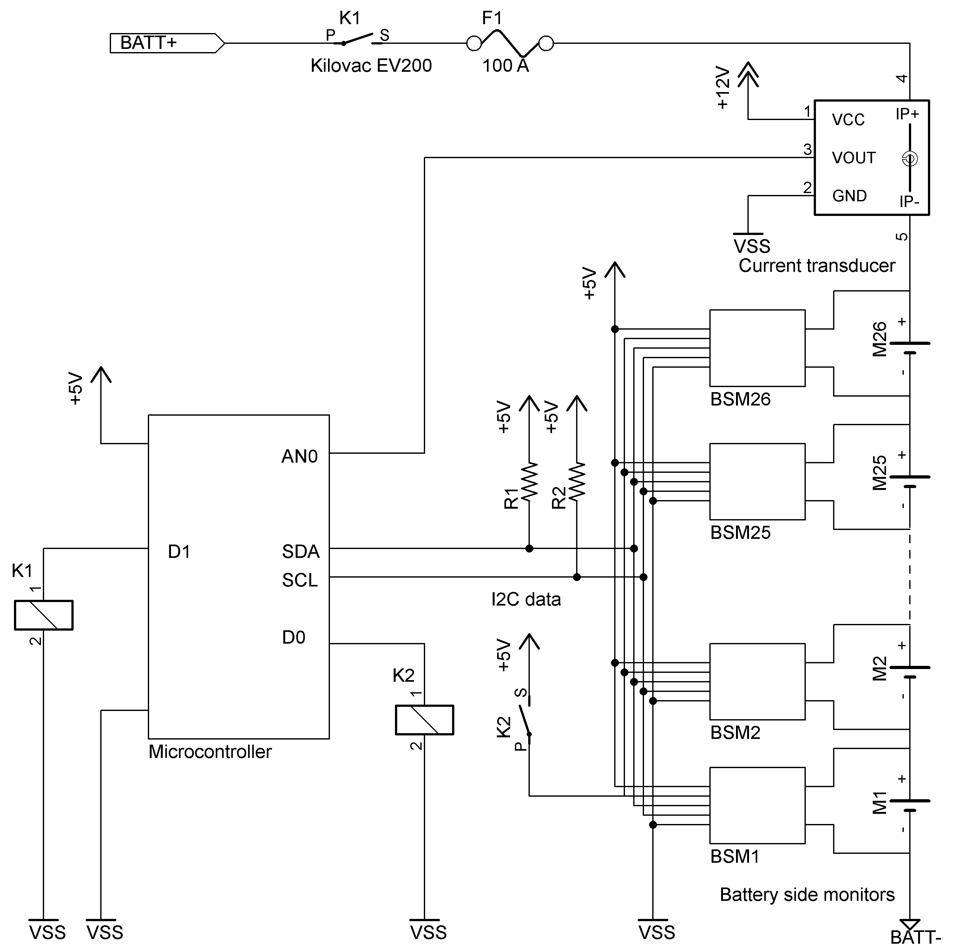

Figure 1: Block diagram of battery protection system

### Battery Side Monitor

A schematic of the battery side monitor circuit is shown below in Figure 2. Each module in the battery pack will have a corresponding battery side monitor circuit; since there are 26 battery modules, the BPS will feature 26 battery side monitors.

The DS2764 battery monitor IC from Dallas Semiconductor was selected to provide voltage and temperature measurements. This sensor is designed to be powered by and monitor a single Li-ion cell; during operation, temperature and voltages are measured, digitized, and made available on an I2C digital bus. Module voltage is measured with 4.88 mV precision and is updated every 3.4 ms while temperature is measured with 0.125°C precision and is updated every 220 ms.

In order to provide ground isolation between each module and the data bus, an Analog Devices ADUM1251 I2C isolator was selected. This device is compatible with the voltage range of Li-ion cells and features bi-directional communication on the I2C data-line; this feature is vital since the central microcontroller has to send commands and receive data on the same wire.

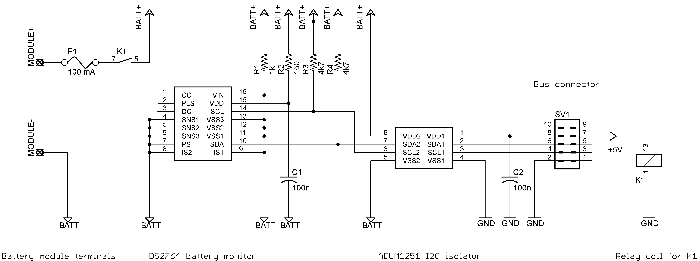

Figure 2: Schematic of battery side monitor circuit

The DS2764 monitor IC and the ADUM1251 I2C isolator IC receive some power directly from its battery module; together they draw approximately 2 – 3 mA through this connection. Therefore, provision is provided to isolate these loads when the BPS is offline or the set-points are exceeded. A Coto 9007-05-40 reed relay (1 Form A: SPST, normally open, non-latching) is used to accomplish this and is indicated by K1 in Figure 2. During normal operation, the central processor circuitry will energize the coils of each relay to connect the battery side circuitry to the module. When the BPS is powered off these relays will open, fully isolating the battery side monitor circuitry from the module.

The battery side monitor circuits will be attached to each module using hot-melt adhesive. The temperature sensor is located internally to the DS2764 IC. As such, when installed the IC case will placed in direct contact with the battery module casing. The battery side monitors are then daisy-chained to the central processor using a 10-pin ribbon cable and 2x5 IDC connectors.

### Current Transducer

A LEM LA-50P closed-loop hall-effect type current transducer will be employed to measure current draw. This sensor is capable of bidirectional current measurement in the range of ±80 A. The closed-loop design allows non-contact measurements, providing galvanic isolation between the current measurement and the sensor output. To avoid accidental connection of high voltages to the central processor circuit, the current transducer will be located on a separate circuit board remote to the central processor.

The LA-50P sensor outputs a small bi-polar current proportional to the current through the sensor at a ratio of 1/2000. This output current will be converted to a voltage via a measurement resistor. An op-amp circuit will be used to scale and level-shift this signal to a voltage in the 0 – 5 V range required by the analog-to-digital converter on the central processor.

### Central Processor

The central processor will consist largely of a PIC18F26K80 microcontroller. This microcontroller features 12-bit analog-to-digital conversion to ensure adequate measurement resolution from the current transducer.[1] This device will continually poll the battery side monitors and current transducer and compare these measurements against the imposed set-points. Temperature measurements will be stored at 1°C precision while voltages will be stored at 4.88 mV precision.

Past experience with this microcontroller and a similar battery side monitor design has shown that this arrangement is capable of an entire system refresh rate of about 100 Hz. In order to prevent spurious readings from causing false disconnection of the battery pack from the car, the central processor will only take action after receiving ten consecutive readings outside of the imposed set-points. This reduces the effective refresh rate to approximately 10 Hz.

The central processor has two essential logic-level output signals: one to control power to the relays on each battery side monitor circuit (*relay state* or D0 in Figure 1) and one to control power to the main battery pack disconnect contactor (*contactor state* or D1 in Figure 1). These outputs are driven low under any fault conditions.

Under normal operation, the driver will momentarily power the BPS from the vehicle’s auxiliary battery. The central processor will assert *relay state* HIGH, causing each battery side monitor to be connected to its battery module. The central processor will then poll each sensor and the current transducer. If the system is found to be within safe limits, the central processor will assert *contactor state* HIGH, closing the battery pack contactor and connecting the battery pack to the car’s high voltage rail. This will cause the car’s 12 V rail (powered by a 96V to 12V DC/DC) to become live. At this point, the BPS will be powered by the 12 V rail and the auxiliary battery is disconnected.

Following the detection of a fault condition, the central processor drives both *relay state* and *contactor state* to logic low, causing disconnection of the battery side monitors from their modules and the battery pack from the high voltage rail of the car. Once a fault condition is asserted it can only be cleared by a hard reset of the BPS (ie – by powering down the solar vehicle and repeating the power-up procedure).

The logic level outputs of the microcontroller are capable of sinking 20 mA; therefore relay driver circuits are required to interface the logic outputs to the battery pack contactor and relays on the battery side monitors. This will be accomplished either using a logic-level relay stage, relay driver IC such as a NUD3112, or an n-MOSFET relay driver circuit.

### Additional Outputs and Debugging Support

The battery protection microcontroller will feature additional outputs to help the race crew in debugging system errors and developing a race strategy. A 2x24 character LCD screen will be installed in the lid of the battery box and will display the last recorded fault condition (location and type of fault), maximum and minimum module voltages, maximum cell temperature, and measured hall-effect sensor current. A data link to the telemetry system will be employed and an additional RS232 debugging port (text output to a terminal) will be available. These communication links will be one-way only and cannot be used to change firmware settings on the BPS microcontroller.

# Regulations Compliance and Scrutineering Demonstration

When constructed, provisions will be taken to ensure and demonstrate compliance with race regulations. In order to facilitate testing during scrutineering, additional battery side monitors identical to those installed in the battery pack will be provided for inspection. An additional connector on the BPS ribbon cable bus will also be provided. This will allow one of these spare sensors to be connected to the BPS in the place of one monitor installed on the battery pack. This spare monitor could then be connected to a power supply voltage reference and placed near a heating element for testing of the voltage and temperature set points.

In order to simulate overcurrent conditions, the microcontroller’s analog input will be disconnected from the current transducer circuitry and connected to test points to allow the injection of an analog voltage. Datasheets for the current transducer and associated circuitry will be provided along with pre-prepared calibration curves. These will be used to demonstrate the relationship between transducer current and analog voltage output.

During testing, the readings from the test points and the BPS status will be visible on the LCD screen attached to the BPS. Additionally, the state of any relays can be observed directly using an ohmmeter and by listening for their triggering.

Finally, the system set points will be rendered static following scrutineering. The set points will be hard-coded into the BPS firmware and cannot be changed without reprogramming the BPS microcontroller. This would only be possible through the replacement of the microcontroller or by accessing the programming pins in-circuit (on-board). As discussed in section 3.2.5, the only data connections accessible from outside the battery enclosure are one-way only (data transmitted from BPS). Once the battery enclosure lid is sealed following scrutineering, the only methods of modifying the BPS set points would firstly involve breaking the battery enclosure seal.

# Concluding Remarks

This report has discussed the design approach taken for the battery protection system being built for use in the ASC2014 entry for the McMaster Solar Car Project. Intent was made to fully report all current information to indicate compliance with race regulations. Should any details appear unclear or contrary to the race rules, the McMaster Solar Car Project welcomes any questions or comments that the reviewers may have.

1. 12-bit precision corresponds to a resolution of 1.22 mV per division. If the current transducer output of ±80 A is scaled to 0 – 5 V, this corresponds to 31.25 mV/A, or approximately 26 mA per division